**String**

**Assignment**

1. Write an application to determine the length of the String str = “Hello World”. (Hint: Use String method).

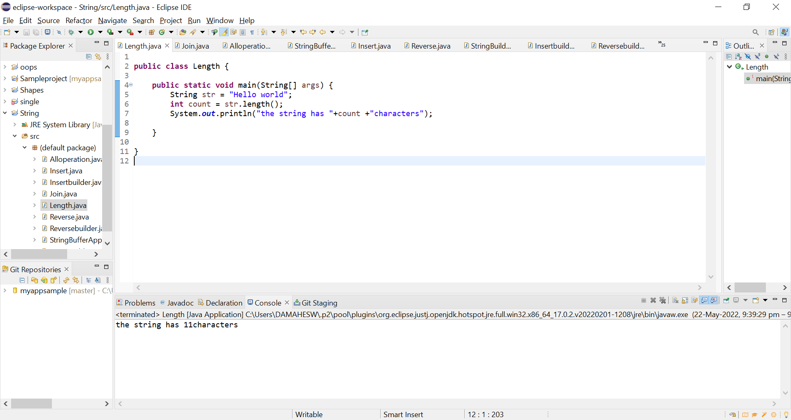

1. Write an application to join the two Strings “Hello, ” & “How are you?” (Hint: Use String method).

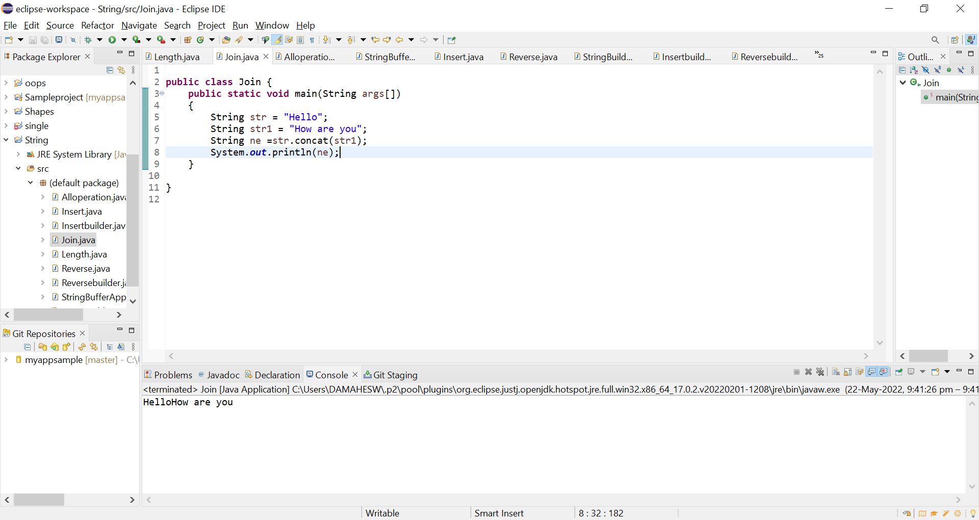

1. Given a String “Java String pool refers to collection of Strings which are stored in heap memory”, perform the following operations (Hint: all operation can be performed using String methods)

a. Print the string to console in lowercase

b. Print the string to console in uppercase

c. Replace all ‘a’ character in the string with $ sign

d. Check if the original String contains the word “collection”

e. Check if the following String “java string pool refers to collection of strings which are stored in heap memory” matches the original

f. If the string does not match check if there is another method which can be used to check if the strings are equal

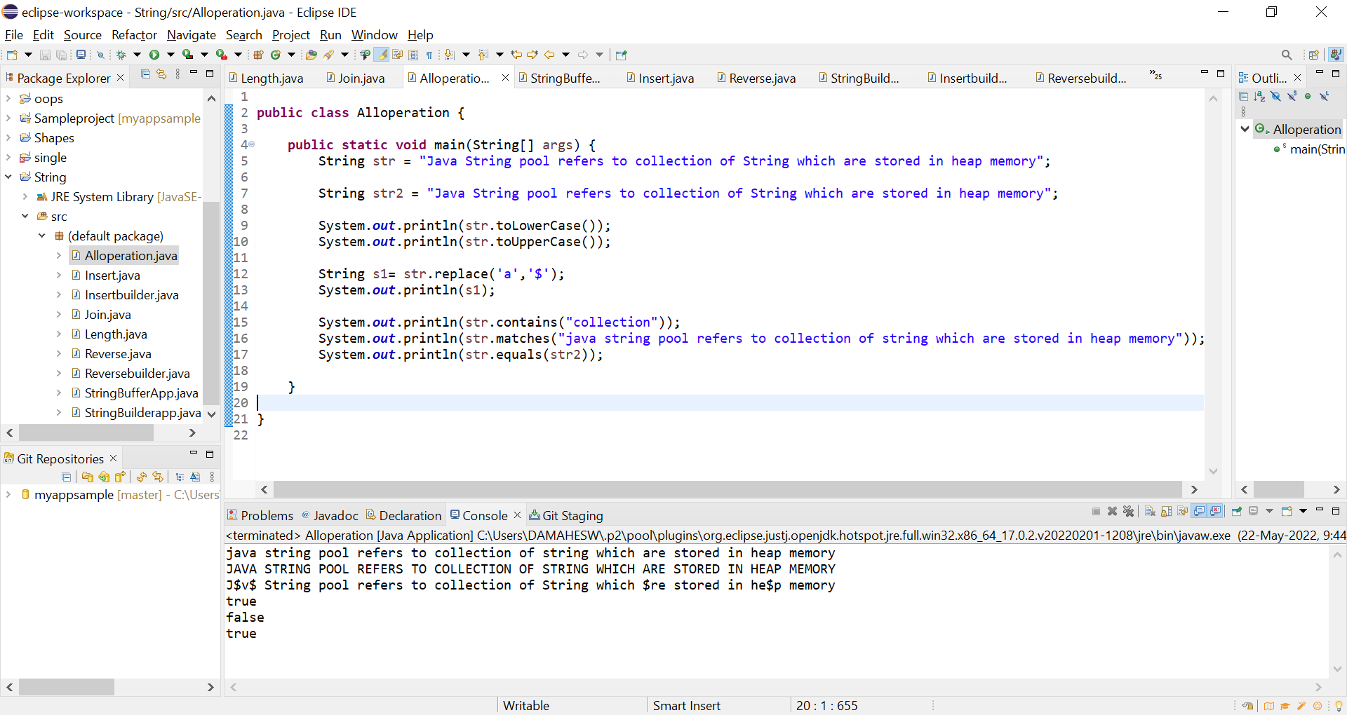

**Assignments on StringBuffer Class**

Note: StringBufferis a peer class of String that provides much of the functionality of strings. String represents fixed-length, immutable character sequences while StringBufferrepresents growable and writable character sequences. StringBuffer may have characters and substrings inserted in the middle or appended to the end. It will automatically grow to make room for such additions and often has more characters preallocated than are actually needed, to allow room for growth.

1. Write an application to append the following strings “StringBuffer”, “is a peer class of String”, “that provides much of“, “the functionality of strings” using a StringBuffer.

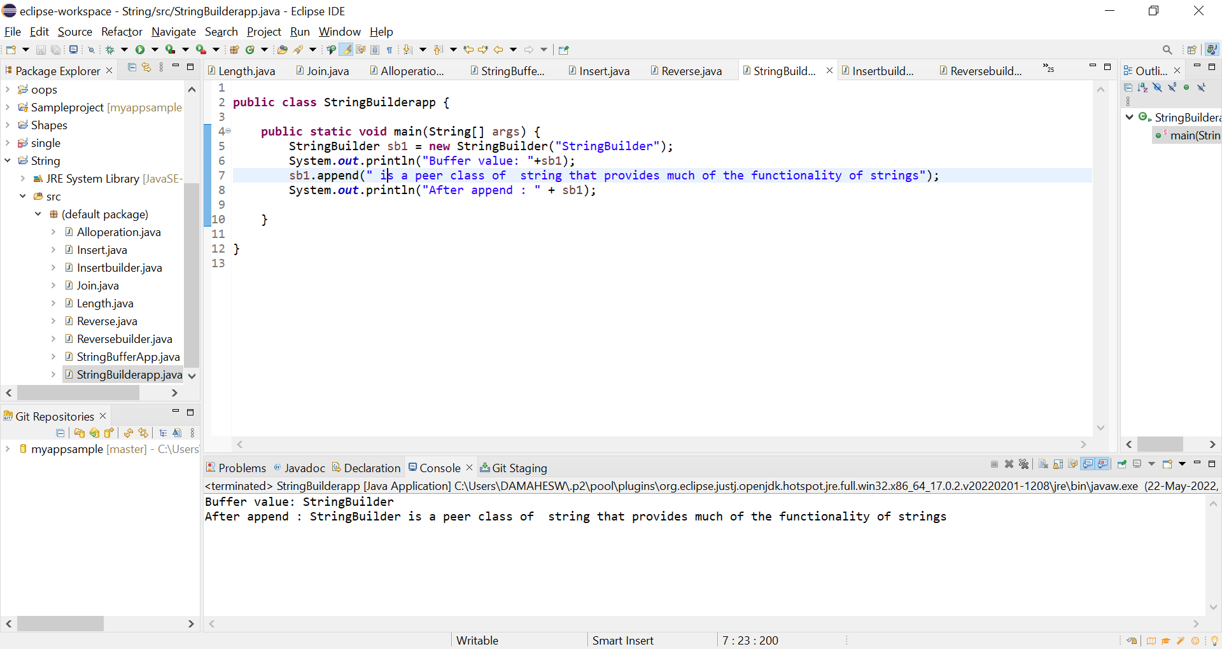

1. Insert the following string “insert text” into the string “It is used to_at the specified index position” at the location denoted by the sign _

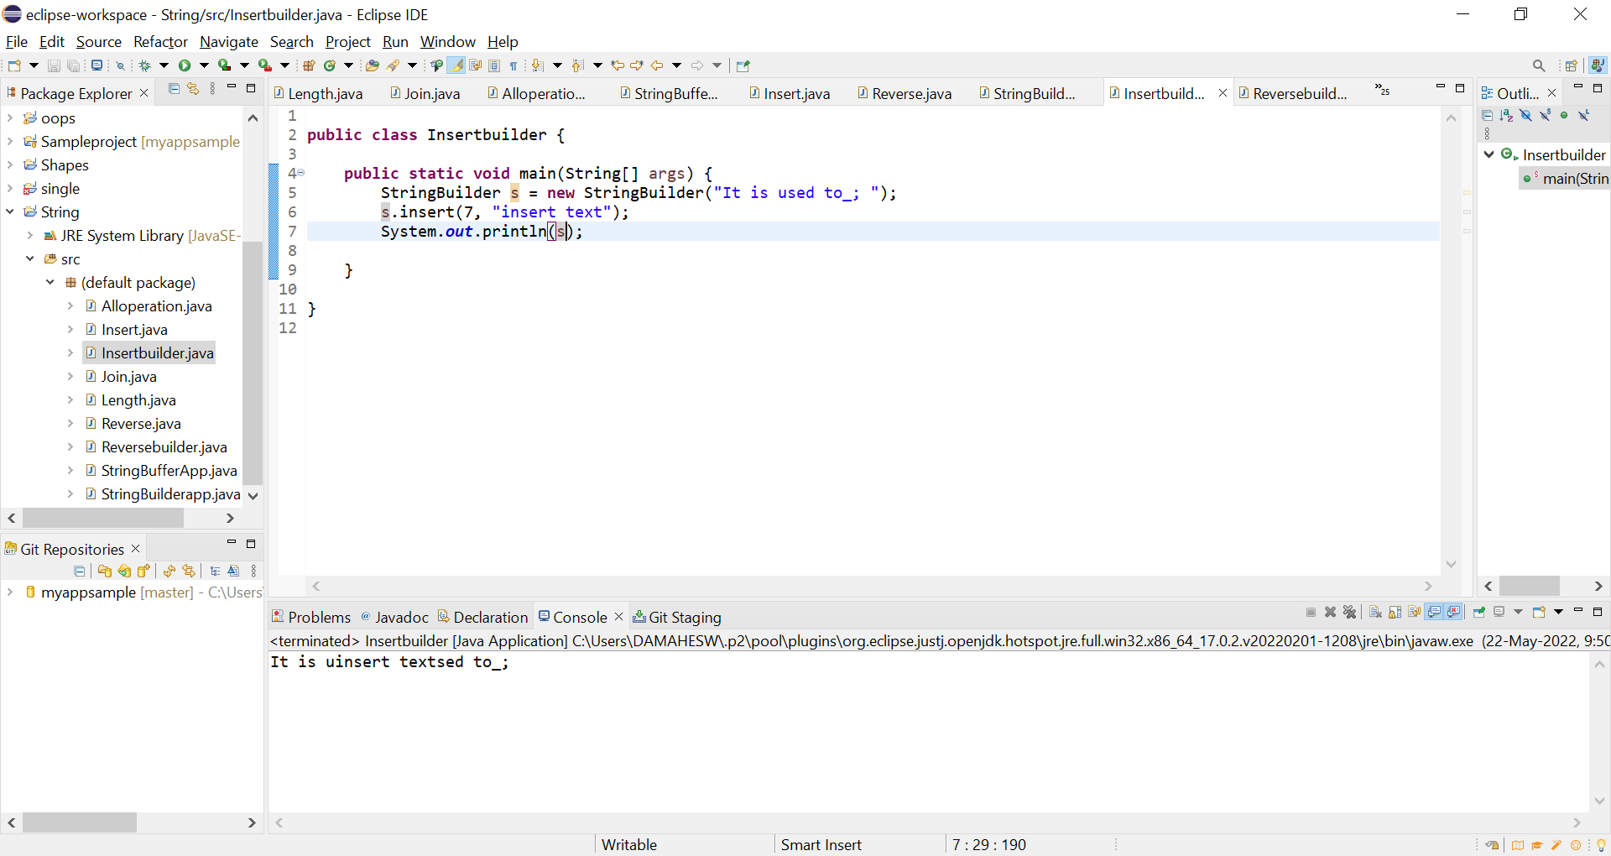

1. Reverse the following string “This method returns the reversed object on which it was called” using StringBuffer Class

